Firmware Update
- Ensure the load is not connected.
- Ensure the output is off.
- This procedure for the Firmware version 1.12 and larger than 1.12
 Note
 | - Insert the USB Flash Drive with \prist\prist_psx |  | (Must put the prist_psx in the \prist)
 | - Press the Function key. The function key will light up. |  | 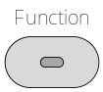
 | - The display will show F-01 on the top and the configuration setting for F-01 on the bottom. | 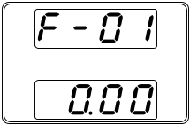
 | - Rotate the voltage knob to change the F setting, until to F-00 |  | 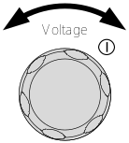
 | - The display will show F-00 on the top and the 0000 for the Password for F-00 | 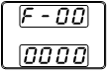
 | - Use the current knob to set the Password for the F-00 setting. The Password is “5 0 0 4” |  | 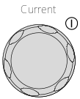
 | - Press the Voltage knob to enter the Calibration Mode. SF- 1 will be displayed when successful.  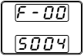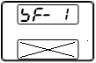 X for don’t care |  | 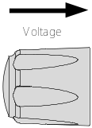
 | - Rotate the voltage knob to change the SF setting, until to SF- 2
 | - The display will show SF- 2 on the top. | 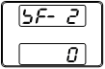
 | - Use the current knob to set the value for the SF- 2. The value is “1”
- Press the Voltage knob to copy the new firmware to the PSW
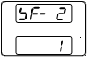
- On progressing, the display will show blew lists.
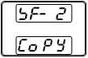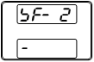
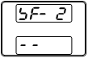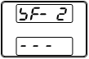
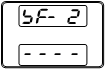
 | - After SF- 2 ok, the system will reboot automatically. 